effect of heat treatment on the corrosion rate of
S45C steel

Dody Prayitno ¹⁾. Joko Riyono ¹⁾. Daisman P. B. Aji ¹⁾. Anisa D. I ¹⁾
¹⁾ Department of Mechanical Engineering. Universitas Trisakti
Corresponding author : dodyprayitno@trisakti.ac.id

ABSTRACT
Parts of North Jakarta are at risk of tidal floods as heavy rainfall hits Jakarta. The Jakarta Regional Disaster Mitigation Agency (BPBD) recorded an increase in water level at the Pasar Ikan floodgate in North Jakarta to 210 centimeters. The floods inundated homes and vehicles such as cars. The parts of car such as S45C steel shaft will corrode when it is in seawater. For a good performance in application a S45C steel should be heat treated (hardening and/or annealing). The aim of this research is to investigate the effect of heat treatment on the corrosion rate of S45C steel in the sea water. A S45C steel plate was cut and machined into some smaller pieces of plates for the experimental samples. The samples were hardened and annealed. Then the samples were immersed in solution of NaCl (5%) and the corrosion rate was obtained by using the weight loss method. Next the corrosion rate data were analysed by MATLAB software. The results show that in hardening process. increasing temperature of heating from 800 ºC to 900 ºC does not affect the corrosion rate. The annealing effect is reducing corrosion rate yet increasing time of exposure does not affect the corrosion rate.

Key word : Hardening. Annealing. Corrosion Rate. Steel

I INTRODUCTION
Parts of North Jakarta are at risk of tidal floods as heavy rainfall hits Jakarta. The Jakarta Regional Disaster Mitigation Agency (BPBD) recorded an increase in water level at the Pasar Ikan floodgate in North Jakarta to 210 centimeters (Jakarta Post. 2020). The New Year’s (2020) floods in Jakarta inundated thousands of homes. buildings. cars and motorcycles across the city. both in poor and wealthy neighborhoods as shown in Figure 1. (Coconuts. 2020). The parts of car such as S45C steel shaft will corrode when it is in seawater. For a good performance in application. a S45C steel should be heat treated such as hardening and/or annealing.
The aim of this research is to investigate the effect of heat treatment on the corrosion rate of S45C steel in the sea water. The research questions are as follows:
- Does the increasing temperature of heating from 800 ºC to 900 ºC affect the corrosion rate?
- Does the annealing process affect the corrosion rate?
- Does the increasing time exposure in NaCl (0.5 %) affect the corrosion rate ?


Figure 1. Floods in Jakarta. (coconuts. 2020)
II STUDY LITERATURE
JIS S45C Steel is a medium strength steel and suitable for shafts studs. For good performance in application the S45C steel can be subjected to various heat treatments such hardening and annealing. In the hardening process (Figure 2.a). the steel is put in a furnce to heat to certain temperature for several hours. The steel is quenched in a water or oil. The hardening effect is increasing hardness. In the annealing process (Figure 2.b). the steel is heated to certainty temperature for several hours. Then the steel is cooled in furnace atmosphere. The annealing decreases hardness.
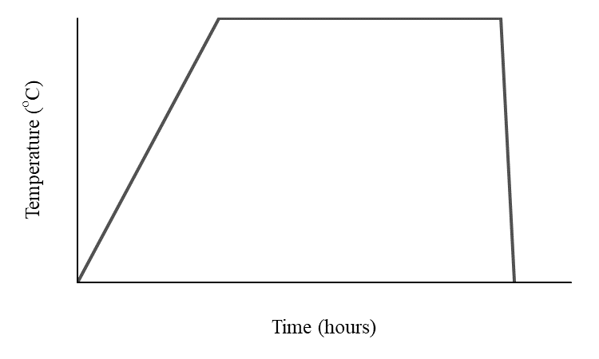 | 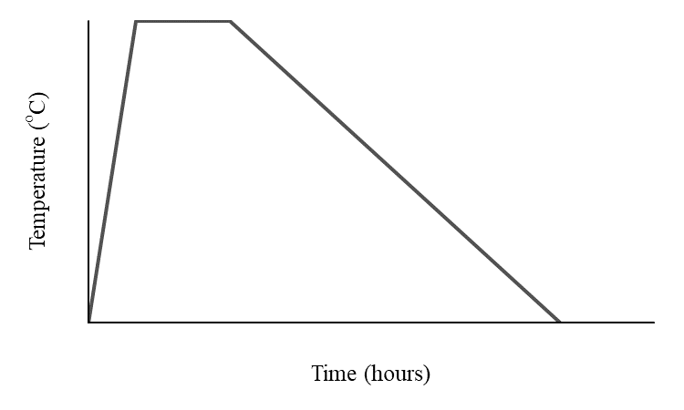
- Hardening | - Annealing

Figure 2. Heat Treatment Process

Corrosion (usually a metal) is gradual destruction by electrochemical and/or chemical reaction with their environment. The metal is refined into a more chemically stable form such as oxide. A corrosion rate is calculated by using the weight loss method. The corrosion rate (CR) is obtained by using Equation 1.

CR = (K x W)/(A x T x D) (1)

Where
CR : corrosion rate (millimeter per year [mmy])
K : a constant (8.76 X 10⁴)
W : mass of loss (gram)
A : area (cm²)
T : time of exposure (hour)
D : density (g/cm³)

In the onshore environment. the corrosion rate of hardened steel (0.65 %C) is 137.47 millimeter per day (mmd) while the normalized steel is 168.44 mmd (Aloysius. 2017).
The increasing temperature of tempering improves the corrosion rate of stainless steel 13Cr3Mo3Ni. The lowest corrosion rate is 0.01717 millimeter per year (mmy) at 500 °C. However. at 600 °C. the corrosion rate is the highest since precipitation of carbide was in the grain boundary (Hadi Perdana. 2017).
Handoko (2017) investigated the effect of heat treatment on the corrosion rate of pipe steel (API 5L Grade B) in solution of NaCl. As shown in Figure 4. the corrosion rate of initial pipe steel was higher than the heat treated steel since the NaCl is 3.3 %. The hardening process reduced the corrosion rate from 2.7 mmy to 2.471 mmy and the full annealing reduced corrosion rate from 2.7 millimiter per year (mpy) to 2.013 mpy.

III RESEARCH METHODOLOGY
The research flowchart is shown in Figure 3. The chemical composition of steel is shown in Table 1. Samples of corrosion test were obtained by cutting and machining the steel plate. The dimension of samples (Figure 4) are as follows. The width is 10 mm. The height is 10 mm and the length is 15 mm. The samples were divided into four groups of 12 pieces. Group 1 and 2 were heated to 800 ºC and held at 800 ºC for 2 hours and followed by quenching in water. Then the Group 1 is annealed at 840 ºC for 1 hour but the group 2. Group 3 and 4 were heated to 900 ºC and held at 900 ºC for 2 hours and continued by quenching in water. The group 3 is annealed at 840 ºC for 1 hour but the group 4. Next all the groups were tested by immersion corrosion test methode according to ASTM G1 (Standard Practice for Preparing. Cleaning. and Evaluation Corrosion Test Specimens) where the solution is NaCl (5%). The corrosion rate (CR) was obtained by using Equation 1.

Table 1. Chemical Composition of S45C Steel (ASTM STEEL. 2020)
C (%) | Mn (%) | P (%) | S (%) | Si (%) | Fe (%)
0.42-0.48 | 0.60-0.90 | 0.03 | 0.035 | 0.15-0.35 | Balance

- RESULTS AND ANALYSIS
The corrotion rates were calculated using Equation (1). The corrotion rate results are shown in Table 2 and 3 based on each time of exposure. The average of corrosion rate is shown in Table 4.

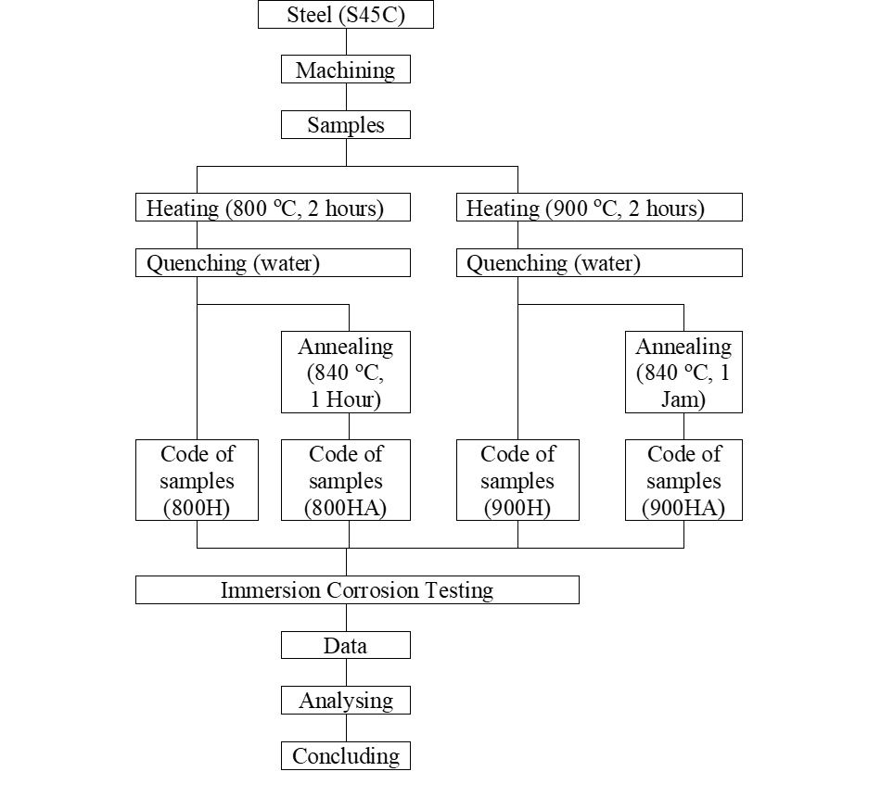
Figure 3. Research Flowchart.

Figure 4. Ilustration Of Sample .

Table 2. Corrosion Rate (T = 96 Hours And 336 H)
 | 96 hours |  |  |  | 336 hours
No | 800H | 800HA | 900H | 900HA | 800H | 800HA | 900H | 900HA
. | (mmy) | (mmy) | (mmy) | (mmy) | (mmy) | (mmy) | (mmy) | (mmy)
1 | 0.571 | 0.549 | 0.568 | 0.334 | 0.489 | 0.188 | 0.421 | 0.254
2 | 0.223 | 0.112 | 0.557 | 0.226 | 0.413 | 0.351 | 0.445 | 0.226
3 | 0.799 | 0.224 | 0.573 | 0.226 | 0.3912 | 0.287 | 0.3936 | 0.226
4 | 0.112 | 0.226 | 0.791 | 0.445 | 0.319 | 0.290 | 0.100 | 0.190
5 | 0.685 | 0.658 | 0.567 | 0.445 | 0.521 | 0.282 | 0.389 | 0.286
6 | 0.223 | 0.112 | 0.334 | 0.226 | 0.413 | 0.319 | 0.445 | 0.161
7 | 0.571 | 0.224 | 0.344 | 0.339 | 0.293 | 0.287 | 0.327 | 0.226
8 | 0.112 | 0.226 | 0.678 | 0.445 | 0.319 | 0.290 | 0.484 | 0.2227
9 | 0.228 | 0.658 | 0.567 | 0.334 | 0.391 | 0.313 | 0.454 | 0.254
10 | 0.334 | 0.112 | 0.556 | 0.452 | 0.381 | 0.319 | 0.477 | 0.096
11 | 0.685 | 0.224 | 0.344 | 0.339 | 0.326 | 0.255 | 0.327 | 0.258
12 | 0.336 | 0.339 | 0.791 | 0.445 | 0.287 | 0.290 | 0.484 | 0.222

Table 3. Corrosion Rate (T = 624 Hours)

 | 624 hoours
 | 800H | 800HA | 900H | 900HA
No. | (mmy) | (mmy) | (mmy) | (mmy)
1 | 0.974 | 1.091 | 0.974 | 0.584
2 | 0.467 | 0.526 | 0.545 | 0.331
3 | 0.493 | 0.337 | 0.532 | 0.519
4 | 0.263 | 0.282 | 0.438 | 0.370
5 | 0.974 | 1.130 | 0.974 | 0.662
6 | 0.506 | 0.526 | 0.526 | 0.350
7 | 0.506 | 0.324 | 0.519 | 0.506
8 | 0.263 | 0.292 | 0.419 | 0.380
9 | 0.974 | 1.130 | 0.974 | 0.701
10 | 0.487 | 0.526 | 0.565 | 0.350
11 | 0.519 | 0.350 | 0.506 | 0.519
12 | 0.272 | 0.292 | 0.399 | 0.399

Table 4. Average of Corrosion Rate (mmy)
No. | Code of samples | Corrosion rate (mmy)
 |  | 96 hours | 336 hours | 624 hours
1 | 800H | 0.406 | 0.379 | 0.559
2 | 800HA | 0.305 | 0.290 | 0.568
3 | 900H | 0.556 | 0.471 | 0.371
4 | 900HA | 0.355 | 0.219 | 0.311

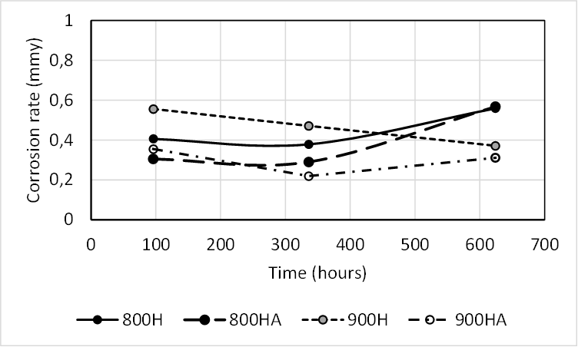
Figure 5.

The Average of Corrosion Rate (mmy) are also shown in Figure 3. The S45C steel (code 800H) has a range of corrosion rate from 0.406 to 0.559 millimeter per year (mmy). The S45C steel (code 800HA) has a range corrosion rate from 0.305 to 0.568 mmy. The code 800H means the S45C steel is heated at 800 ºC and quenched into water. The Code 800HA means the S45C steel (800H) is annealed . The annealing reduces corrosion rate of steel.
The S45C steel (code 900H) has a range of corrosion rate from 0.556 to 0.371 millimeter per year (mmy). The steel (code 900HA) has a range corrosion rate from 0.355 to 0.311. The annealing reduces corrosion rate of steel.
In order to answer the research question. the corrosion rate data were analysed by MATLAB software. The matlab results are shown in Figure 6.

Interpretasion of output according to the matlab results:
1. In order to answer the question research “ Does the increasing temperature of heating from 800 oC to 900 oC affect the corrsosion rate?” The group 800H and 900H are analysed while the hypothesis H0 versus H1. H0 : type of group does not affect on the corrosion rate. H1: type of group affect on the corrosion rate.

Based on to the matlab result. p-value is 0.065. It is concluded H0 is accepted with significant level 0.05. Type of groups does not affect on the corrosion rate or increasing temperature from 800 oC to 900 oC does not affect the corrosion rate.

2. In order to answer the question research. “Does the annealing process affect the corrosion rate?” the “Non annealing” and “Annealing” is analysed. Hypothesis H0 versus H1. H0 : Annealing does not affect the corrosion rate. H1 : annealing affects the corrosion rate.

Based on to the matlab result. p-value is 0.006. It is concluded H1 is accepted with significant level 0.05. Annealing affects the corrosion rate .

3. In order to answer the question research. “Does the increasing time exposure in NaCl (0.5 %) affect the corrosion rate ? The interaction between “Type of group” and “Annealing ” is analysed. The hypothesis H0 versus H1. H0 : the interaction both of factor does not affect the corrosion rate. H1 : the interaction both of factor affects the corrosion rate.

Based on to the matlab result. p-value is 0.346. It is concluded H0 is accepted with significant level 0.05. The interaction both factor does not affect the corrosion rate or the increasing time exposure in NaCl (0.5%) does not affect the corrosion rate.

General Factorial Regression: corrosion rate versus GROUP; ANNEALING

Factor Information

Factor Levels Values
GROUP 2 800H; 900H
ANNEALING 2 Non Annealing ; Annealing

Analysis of Variance

Source DF Adj SS Adj MS F-Value P-Value
Model 3 0.42324 0.14108 4.25 0.010
Linear 2 0.39315 0.19658 5.93 0.005
GROUP 1 0.11900 0.11900 3.59 0.065
ANNEALING 1 0.27415 0.27415 8.27 0.006
2-Way Interactions 1 0.03009 0.03009 0.91 0.346
GROUP*ANNEALING 1 0.03009 0.03009 0.91 0.346
Error 44 1.45893 0.03316
Total 47 1.88217

Model Summary

S R-sq R-sq(adj) R-sq(pred)
0.182092 22.49% 17.20% 7.75%

Coefficients

Term Coef SE Coef T-Value P-Value VIF
Constant 0.4056 0.0263 15.43 0.000

GROUP
800H -0.0498 0.0263 -1.89 0.065 1.00
ANNEALING
Non Annealing 0.0756 0.0263 2.88 0.006 1.00
GROUP*ANNEALING
800H Non Annealing -0.0250 0.0263 -0.95 0.346 1.00

Figure 6. MATLAB results

V CONCLUSIONS
In hardening process. increasing temperature of heating from 800 ºC to 900 ºC does not affect the corrosion rate. The annealing decreases the corrosion rate. However, increasing time of exposure does not affect the corrosion rate.

References
The Jakarta Post. 2020. Parts of North Jakarta at risk of tidal floods as heavy rainfall hits Jakarta. Jakarta. thu. April 30. 2020. 02:52 pm. Availabel online https://www.thejakartapost.com/news/2020/04/30/parts-of-north-jakarta-at-risk-of-tidal-floods-as-heavy-rainfall-hits-jakarta.html )
Coconuts. 2020. “At least 24 dead. thousands displaced in Jakarta’s New Year’s floods”. Coconuts Jakarta Jan 2. 2020 | 11:02am Jakarta time. Available online https://coconuts.co/jakarta/news/at-least-24-dead-thousands-displaced-in-jakartas-new-years-floods/.
Cahya Sutowo. Budi Priyono. 2014. “Analisa Kegagalan Pada Poros Baja Karbon S45C Aplikasi Komponen As Sink Roll”. Prosiding Seminar Nasional Sains dan Teknologi Universitas Muhammadiyah Jakarta. ISSN 2407-1846
https://www.steelindopersada.com/2016/11/heat-treatment-of-carbon-steel-aisi-s45c-steel-grades.html
Aloysius bagus cahyadi (2017). PENGARUH LINGKUAN PANTAI TERHADAP LAJU KOROSI DAN SIFAT MEKANIK PADA BAJA KARBON SEDNGAN DENGAN PERLAKUAN QUENCHING. skripsi. teknik mesin . Universitas Sanata Dharma. yogyakarta. 2017
Hadi Perdana. Moch. Syaiful Anwarb. Andinnie Juniarsiha dan Efendi Mabrurib (2017)“PENGARUH SUHU DAN WAKTU TEMPERING TERHADAP KEKERASAN. STRUKTUR MIKRO. DAN LAJU KOROSI BAJA TAHAN KARAT MARTENSITIK 13Cr3MO3Ni” Metalurgi (2017) 1: 37 - 44 . Available online at www.ejurnalmaterialmetalurgi.com
Handoko. Bayu Dwi (2017) ANALISIS PENGARUH HEAT TREATMENT TERHADAP LAJU KOROSI DAN SIFAT MEKANIS MATERIAL PIPA BAJA API 5L GRADE B DI LINGKUNGAN LAUT. Undergraduate thesis. Institut Teknologi Sepuluh Nopember.
https://www.astmsteel.com/product/jis-s45c-steel-machine-structural/

